Paper Title

Full abstract for ICMR2025AKITA within 2 pages

Mitsutoshi JIKEI1, Kazuya MATSUMOTO1, Seiji KUMAGAI2

1 Department of Materials Science, Graduate School of Engineering Science, Akita University, 1-1 Tegatagakuen-machi, Akita 010-8502, Japan

2 Department of Mathematical Science and Electrical-Electronic-Computer Engineering, Graduate School of Engineering Science, Akita University, 1-1 Tegatagakuen-machi, Akita 010-8502, Japan

E-mail: abcdefg@gipc.akita-u.ac.jp (Seiji KUMAGAI)

**Keywords:** Manuscript, needing, 3 to 5 keywords

1 INTRODUCTION

The background and purpose of the present study should be explained in this section. References should be expressed in [1], [2-10] or [3,5,7].

2 EXPERIMENTAL METHODS

2.1 Material preparation

2.1.1 Raw materials

The sub-heading can be used.

2.1.2 Synthesis

Deeper sub-heading like 2.1.2.1 can be also used.

2.2 Equations

A formula preparation tool embedded in MS WORD can be used. Equations should be sequentially numbered as follows.

$\sin{α}±\sin{β}=2\sin{\frac{1}{2}\left(α±β\right)}\cos{\frac{1}{2}\left(α∓β\right)}$ (1)

$f\left(x\right)=a_{0}+\sum_{n=1}^{∞}{\left(a_{n}\cos{\frac{nπx}{L}}+b_{n}\sin{\frac{nπx}{L}}\right)}$ (2)

3 RESULTS AND DISCUSSION

3.1 Tables

Tables must be set as part of the text, have captions centered over the tables, and be numbered sequentially. All the tables should be placed as close as possible to the relevant sections where their contents are explained.

Table 1. Example of table format.

|  |  |  |  |
| --- | --- | --- | --- |
| Sample | Mass (g) | Diameter (mm) | Thickness (mm) |
| A | 1.25 | 10.2 | 2.46 |
| B | 2.46 | 15.4 | 3.69 |

3.2 Figures

Figures must also be set as part of the text. All figures should be numbered sequentially and captioned. The caption should be written below. Figures should be embedded in the document and be avoided to group them at the end of manuscript. All the figures should be placed as close as possible to the relevant sections where their contents are explained. Please use “Figure 1” instead of the abbreviation of “Fig. 1” throughout the manuscript. For example, a relationship between time and electromotive force for battery A is shown in Figure 1.

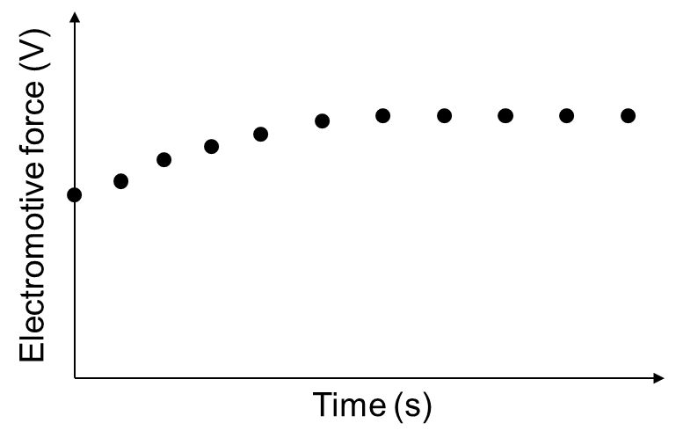

Figure 1. Example of figure showing the relationship between time and electromotive force for battery A. A standard width of figures is 100 mm. But, the size of figures can be freely varied.

4 CONCLUSIONS

The present study revealed that ….

ACKNOWLEDGEMENT

Acknowledgement is optional. The funding information should be described here.

REREFENCES

[1] Please provide the simple text data for the references section to facilitate the final online publication.

[2] Chng C.J.; Ma X.; Abe Y.; Kumagai S., Hard carbon/graphite composite anode for durable lithium-ion capacitor, *J. Energy Storage* **92,** 112193 (2024).

[3] Abe Y.; Sawa K.; Tomioka M.; Kumagai S., Electrochemical performance of LiNi1/3Co1/3Mn1/3O2 cathode recovered from pyrolysis residue of waste Li-ion batteries, *J. Electroanal. Chem.* **922**, 116761 (2022).

[4] Jikei M.; Suzuki M.; Itoh K.; Matsumoto K.; Saito Y.; Kawaguchi S., Synthesis of hyperbranched poly(L-lactide)s by self-polycondensation of AB2 macromonomers and their structural characterization by light scattering measurements, *Macromolecules* **45**, 8237-8244 (2012).

[5] Jikei M.; Yamaya T.; Uramoto S.; Matsumoto K., Conductivity enhancement of PEDOT/PSS films by solvent vapor treatment, *Int. J. Soc. Mater. Eng. Resour.* **20**, 158-162 (2014).

APPENDIX

Appendix is optional.

**Submission of Manuscript**

Send a Word-file of your manuscript by E-mail to:

|  |
| --- |
| ICMR2025AKITA Program Committee  Editorial office of International Conference on Materials Engineering for Resources (ICMR)  c/o Akita University, Tegata Gakuen-machi,  Akita, 010-8502 JAPAN    Tel・Fax: +81-18-889-2439  　E-mail address:　 icmr@gipc.akita-u.ac.jp  s_bussei@gipc.akita-u.ac.jp  See also the site of  　http://www.gipc.akita-u.ac.jp/~smerj/ |